HTML Page Title

📘 Definition
# Source: AI Source: Provided by: [Data Path: Persons Table -> ID Column: 1, Name_En Column: Motasem Essam] -> From: [ChatGPT] on [5/6/2026]
The HTML page title is the text shown in the browser tab that represents the webpage.
It helps users and search engines understand what the page is about.

🔹 <title> Element
# Source: AI Source: Provided by: [Data Path: Persons Table -> ID Column: 1, Name_En Column: Motasem Essam] -> From: [ChatGPT] on [5/6/2026]
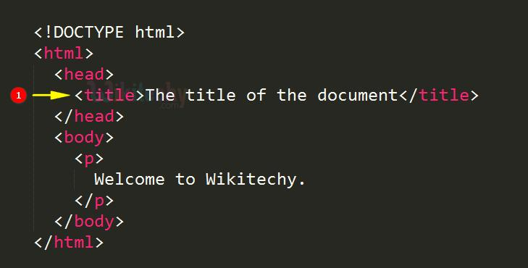
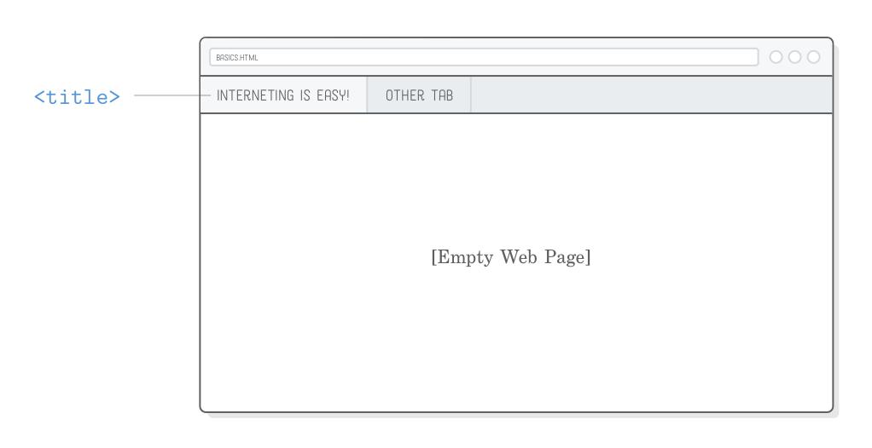
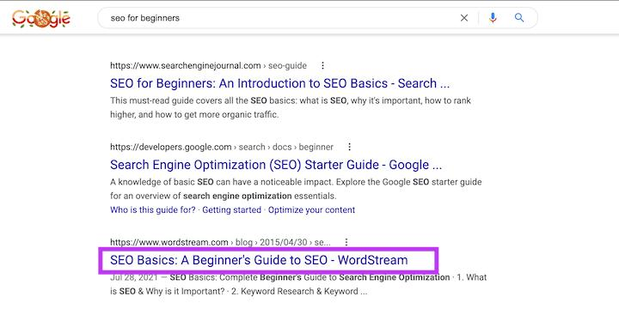
The <title> element is used inside the <head> section to define the page title.

💻 Example

Full Example
# Source: AI Source: Provided by: [Data Path: Persons Table -> ID Column: 1, Name_En Column: Motasem Essam] -> From: [ChatGPT] on [5/6/2026]
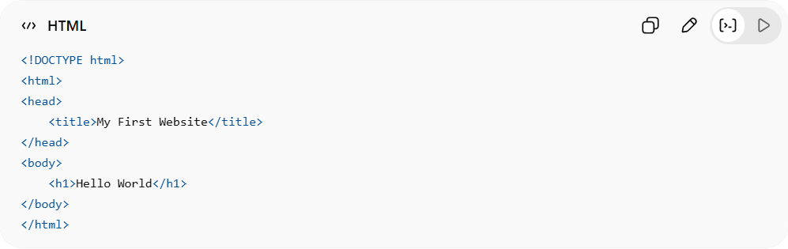
<!DOCTYPE html>
<html>
<head>
<title>My First Website</title>
</head>
<body>
<h1>Hello World</h1>
</body>
</html>

Real Example
# Source: ScreenShot Source: Provided by: [Persons Table -> ID Column: 1, Name_En Column: Motasem Essam] -> Tool: [Automation Table -> ID Column: 16, Name_En Column: Screen Capture] -> From [Operating System: Windows] on [5/6/2026]
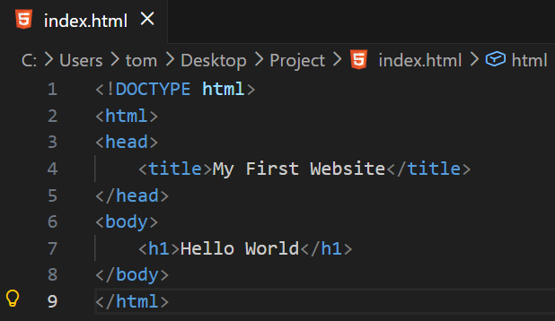
<!DOCTYPE html>
<html>
<head>
<title>My First Website</title>
</head>
<body>
<h1>Hello World</h1>
</body>
</html>

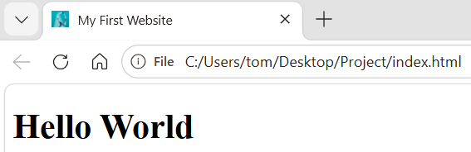

🧠 Simple idea
# Source: AI Source: Provided by: [Data Path: Persons Table -> ID Column: 1, Name_En Column: Motasem Essam] -> From: [ChatGPT] on [5/6/2026]
- <title> element = code that sets the title
- Page title = what you actually see in the browser tab

⚙️ Where it is used
# Source: AI Source: Provided by: [Data Path: Persons Table -> ID Column: 1, Name_En Column: Motasem Essam] -> From: [ChatGPT] on [5/6/2026]
- 🌐 Browser tabs
- 🔍 Search engine results (Google title)
- 📑 Bookmarks

📄 What is a Good Title?
# Source: AI Source: Provided by: [Data Path: Persons Table -> ID Column: 1, Name_En Column: Motasem Essam] -> From: [ChatGPT] on [5/6/2026]
A good title is a short and clear name that correctly describes the content of a webpage, document, or article.

✨ Features of a Good Title
# Source: AI Source: Provided by: [Data Path: Persons Table -> ID Column: 1, Name_En Column: Motasem Essam] -> From: [ChatGPT] on [5/6/2026]
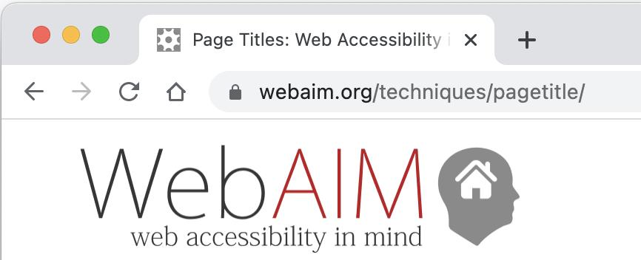
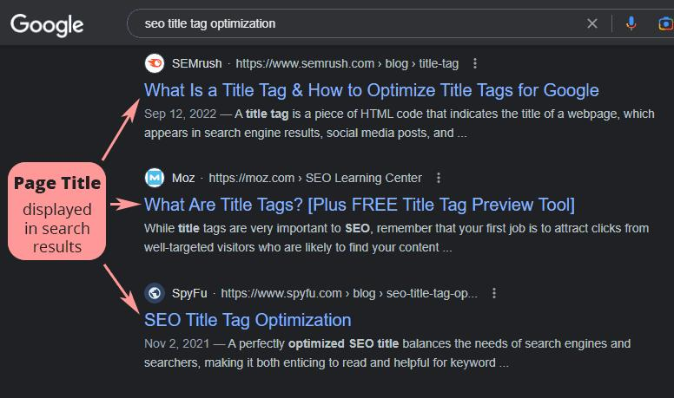
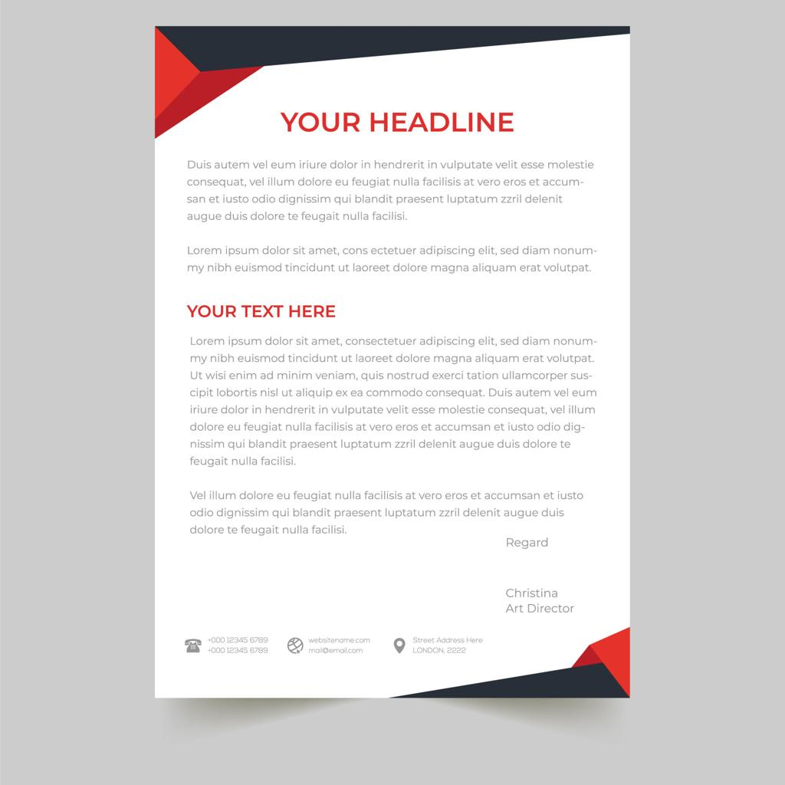
A good title should be:
- Clear → easy to understand
- Short → not too long or confusing
- Descriptive → tells what the page is about
- Relevant → matches the content of the page
- Unique → not copied from others

🧠 Examples
# Source: AI Source: Provided by: [Data Path: Persons Table -> ID Column: 1, Name_En Column: Motasem Essam] -> From: [ChatGPT] on [5/6/2026]
👍 Good Titles
- “Learn HTML Basics”
- “Introduction to Computer Science”
- “How to Use RGB Color Model”
👎 Bad Titles
- “Page 1”
- “My Stuff”
- “Untitled Document”

🌐 Why good titles are important
# Source: AI Source: Provided by: [Data Path: Persons Table -> ID Column: 1, Name_En Column: Motasem Essam] -> From: [ChatGPT] on [5/6/2026]
- Help users understand the page quickly
- Improve search engine ranking (SEO)
- Make webpages easier to find in tabs and bookmarks

🚀 In short:
# Source: AI Source: Provided by: [Data Path: Persons Table -> ID Column: 1, Name_En Column: Motasem Essam] -> From: [ChatGPT] on [5/6/2026]
A good title is a clear, short, and meaningful name that explains what a webpage or document is about.

🚀 In short:
# Source: AI Source: Provided by: [Data Path: Persons Table -> ID Column: 1, Name_En Column: Motasem Essam] -> From: [ChatGPT] on [5/6/2026]
The <title> element defines the page title, which appears in the browser tab and helps identify the webpage.

